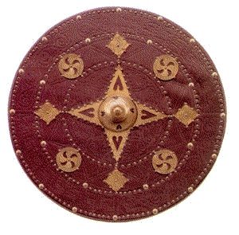
TARGE
Kirriemuir Wargames Club
Painting Competition Entrance Form
Name
Address
Telephone Number
Email Address
Club Member | Y/N

Entry Category | Entry Description | Entry Number
Add rows as required.

Entrance Fee: £1 per entry

For entry category requirements visit: http://kirriemuirwargames.co.uk/TARGE
The entry description will be used to publish the results on the club website.
Entry numbers will be assigned on the day.

